Whole numbers on a number line
Let’s understand first what is a number line? A pictorial representations of numbers evenly marked on a straight line is known as a number line.
- To mark whole numbers on a number line draw a horizontal line and mark a point on it as 0.
- Extend this line towards right direction.
- Starting from 0, mark points 1, 2, 3, 4, 5, 6, 7, 8, 9….on a line at equal distance towards right side.
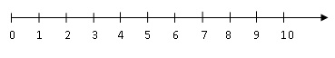
- There is no whole number on the left of zero. Therefore zero is the smallest whole number.
- A whole number is greater than all the whole numbers which lie to the left of it on the number line.
- A whole number is less than all the whole numbers which lie to the right of it on the number line
- The number line also helps us to compare two whole numbers. i.e., to decide which of the two given whole numbers is greater or smaller.
- Therefore we can say that 5 is less than 9 and write 5 < We can also say that 5 is greater than 4 and write 5 > 4.
